1. MINIMAX ALGORITHM
AIM
To implement the Minimax algorithm in Python for a Tic-Tac-Toe game, where the computer selects the best possible move against the player.
OBJECTIVE
· To understand the Minimax decision-making algorithm.
· To implement a game between a human and computer.
· To make the computer choose the optimal move.
· To determine the winner or draw.
ALGORITHM
1. Start the program.
2. Initialize the Tic-Tac-Toe board.
3. Define all possible winning combinations.
4. Accept the player's move manually.
5. Check whether the player has won.
6. If not, apply the Minimax algorithm to find the best computer move.
7. Place the computer's move on the board.
8. Check whether the computer has won.
9. Repeat the process until a player wins or the board is full.
10. Display the winner or draw.
11. Stop.
FLOWCHART:
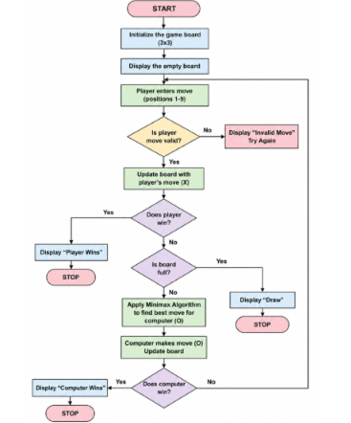
PYTHON CODE:
b=[" "]*9
w=[(0,1,2),(3,4,5),(6,7,8),(0,3,6),(1,4,7),(2,5,8),(0,4,8),(2,4,6)]
def win(p): return any(all(b[i]==p for i in x) for x in w)
def mini(maxi):
if win("O"): return 1
if win("X"): return -1
if " " not in b: return 0
s=[]
for i in range(9):
if b[i]==" ":
b[i]="O" if maxi else "X"
s.append(mini(not maxi)); b[i]=" "
return max(s) if maxi else min(s)
for t in range(9):
print(b[0:3],b[3:6],b[6:9])
if t%2==0:
p=int(input("Enter position (1-9): "))-1
if b[p]!=" ": continue
b[p]="X"
else:
m=max((mini(False),i) for i in range(9) if b[i]==" ")[1]
b[m]="O"
if win("X"): print("You Win!"); break
if win("O"): print("Computer Wins!"); break
else: print("Draw!")
OUTPUT:
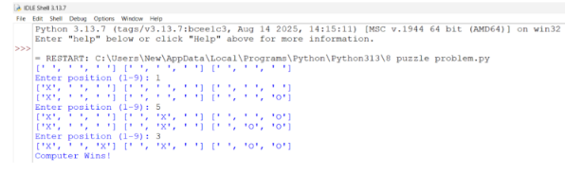
RESULT:
Thus, the Tic-Tac-Toe game was successfully implemented in Python using manual input. The program correctly identifies the winner or declares a draw.

